Asian Rowing Master Regatta, XiaMen China

- Invitation
The Asia Rowing Federation is pleased to invite crews to compete at the Asian Rowing Masters Regatta at XiaMeng, FuJian.

Organized by | : | Asian Rowing Federation
Supported by | : | China Rowing Association
Competition Date | : | 22-23 Oct 2016
Venue | : | JIMEI LAKE Rowing Centre, XIAMENG, FUJIAN
Entry Deadline | : | 20 Sept 2016 12:00 midnight (BeiJingTime)
LIMITED ENTRY | : | Due to limited number of boats available, there is a limited quota in each event. The will arrange the boats after receiving all the Entry Forms. The final entries of each team will be confirmed by 20 Sept 2016

- City Introduction:

Xiamen is a costal city of Fujian Province. Xiamen (also called Amoy in history) is an island city with a rich and dramatic history, replete with pirates, rebel leaders, and European merchants. Now linked to mainland Fujian by a causeway, Xiamen retains a strong international flavor. Known in the West as Amoy, Xiamen has a long history as a port city, and later became a center of British trade in the 19th century. Their foreign settlements, later taken over by Japanese invaders at the start of World War II, were established on the nearby small Gulangyu Island. Many of the old treaty-port and colonial buildings in Western styles survive. Xiamen was declared one of China’s first Special Economic Zones in the early 1980’s, taking advantage of the city’s heritage as a trading center and the proximity to Taiwan. Today Xiamen is one of China’s most attractive and best-maintained resort cities.

As an important city in the southeastern coast of China. Xiamenis one of the four special economic zones which are the earliest opening-up zones in China. Xiamen has been well known as an important foreign trade port in history.
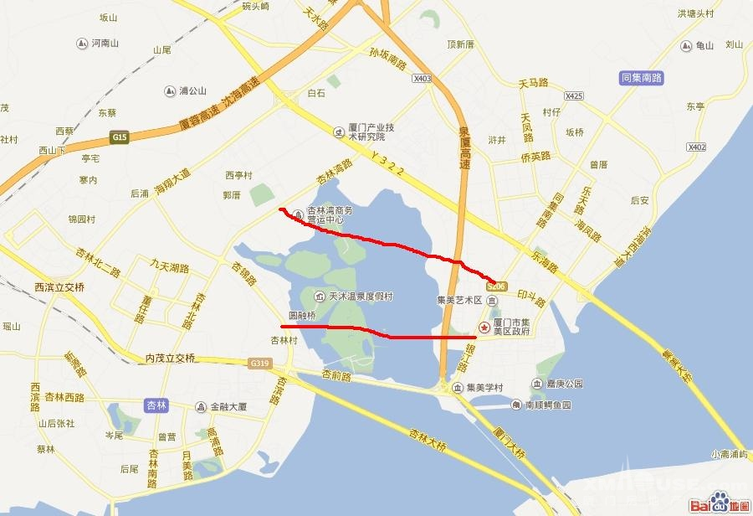

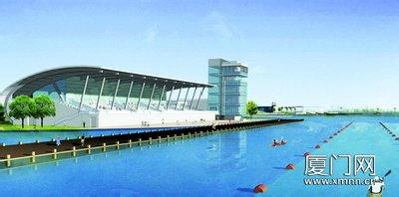
- Race Distance
All events will be 1000 meters and 500 meters, from a fixed start.

- Events

The Regatta will consist of the following events:
Men’s 8+, Men’s 2X; Men’s 4X
Women’s 8+, Women’s 2X, Women’s 4X
Mix 2x, Mix 4X

Note 1: | The Masters events are held according to the FISA Masters Categories as follows:-
 | Category A | Minimum age: | 27 years
 | Category B | Average age: | 36 years or more
 | Category C | Average age: | 43 years or more
 | Category D | Average age: | 50 years or more
 | Age categories do not apply to coxswains. Each competitor shall be responsible for his/her own health and fitness. Every Masters rower must be in a position to prove his/her age by presentation of an official document (passport or any identity card).
Note 2 | Crews of different Masters Age categories and gender may be rowed in the same heat if there are less than six entries in any category. Medals will be awarded based on the respective categories.

- Rules of Racing
The races shall be rowed in accordance with the Rules of Racing of FISA.

- Prize

Medals will be presented for the first placed crew/s in each event.

- Entries Fee

Double(2x) | USD$100/ crew/ event
Quadruple(4x) | USD$200/crew/event
Eight (8+) | USD $ 450/ crew/ event

**Entry Fee includes the fee for Rent Boats..

- Entry Procedures
8.1 | Entry Forms and other necessary information: Entries can be sent either by e-mail or fax. Deadline of Submission 20 Sept 2016.

8.2 | Entries will not only be accepted from rowers who are current ARF Registered Rowers.

8.3 | Every crew enter and compete under the name of a Club or Organization registered with the ARF.

8.4 | Each competitor shall be responsible for his/her own health and fitness and able to swim at least 50 meters in light clothing.

8.5 | Double Entry Fee will be charged after the deadline of the final entry. Late entries will only be accepted if there are available spaces and will NOT be accepted after the publication of the draw. Late entries, where accepted, will be required to pay double the normal entry fee. The ARF reserves the right to reject any entry.

- The Draw
The draw will be conducted on 21 Oct, 2016 at BeiJing time 7:30 p.m. at the JIMEI Rowing Centre.

- Arrangement for Entry Fee in case of Event Cancelled
10.1 | In view of the need of the CRA to bear the logistics and set-up costs, only 50% of the paid entry fee will be refunded in case of the regatta cancelled.

- 11. Race Uniform
Race uniform should be identical.

12.More details about payment will come soon.

13. Accommodation, Lunch Box & Transportation Services will support from OG. The cost will pay by rower. More detail will come soon.

- 14. Weather
During the time of the Regatta, the weather is expected to be dry and temperature
generally in the range of 22℃ to 26℃.

- 15. Your Action Deadlines

16. Enquiries and Correspondence

XiaMen OC

Contact person: ZHANG Ning
Telephone: +86-18860005093
Email: 522759201@qq.com

All the visitors and supporters are very welcome to take part in the Regatta! If you notice that any crews interested in competing but do not receive this Bulletin, please furnish them with this or ask them to contact the Organizing Committee directly.

Look forward to seeing you and your team in XiaMeng of China!

Organizing Committee
Asian Rowing Masters Regatta

